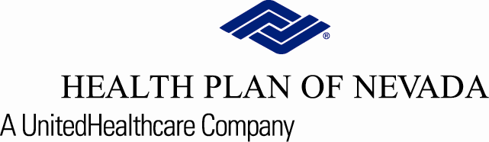

Physicians, Practice Managers and Staff: YOU’RE INVITED!
Health Plan of Nevada Medicaid and Nevada Check Up

Wednesday, July 27, 2022 from 11 a.m. to noon

Please join us for an informational webinar about Health Plan of Nevada’s Medicaid plan and Nevada Check Up.

Meeting Topics:

- Cultural Competency
- Hospice and Palliative Care
- Health Education and Wellness programs
- Behavioral Health contacts
- …and more

Pre-registration is required in order to receive the invite. Please secure your spot by filling out the form below and returning to us no later than Monday, July 25, 2022. The webinar invite will be sent to the email address(es) provided one day prior to the meeting date.

Completed RSVP should be emailed to PRI@uhc.com.

Practice/Physician Name: | TAX ID#:
Attendee email: | Attendee email:
Attendee email: | Attendee email:
Attendee email: | Attendee email:
Attendee email: | Attendee email:

For More Information:
If you have questions, please contact your Health Plan of Nevada Physician Advocate team at
702-242-7088 or 1-800-745-7065, Option 2 then option 5.

Thank you,
The Health Plan of Nevada Team
Provider Relations

